**Aim :- Data Modelling and Analytics with Pivot Table in Excel.**

Data Model is used for building a model where data from various sources can be combined bycreating relationships among the data sources. A Data Model integrates the tables, enabling

extensive analysis using PivotTables, Power Pivot, and Power View.

A Data Model is created automatically when you import two or more tables simultaneously

from a database. The existing database relationships between those tables is used to create the

Data Model in Excel.

**Step 1 −** Open a new blank Workbook in Excel.

**Step 2 −** Click on the DATA tab.

**Step 3 −** In the Get External Data group, click on the option From Access. The Select Data

Source dialog box opens.

**Step 4 −** Select Events3_Data.mdb, Events Access Database file.

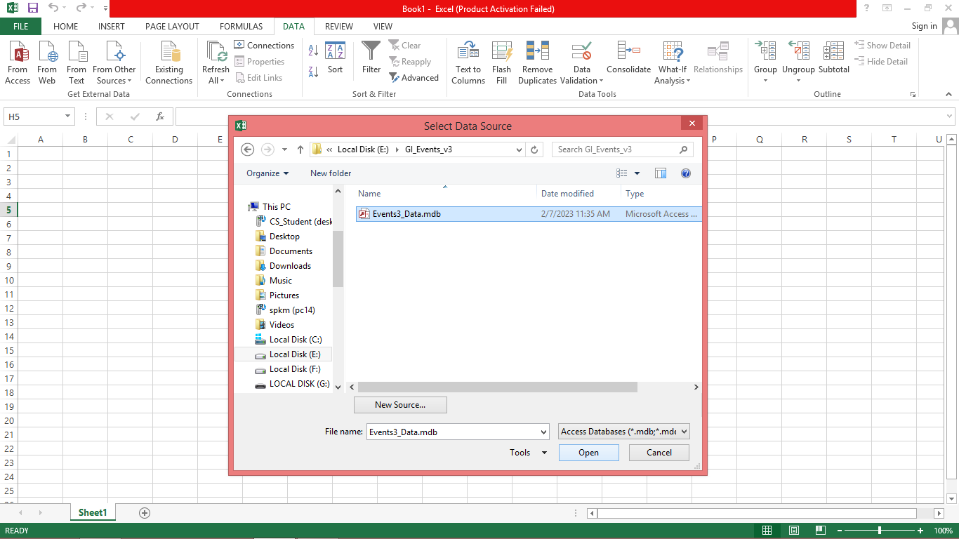

**Step 5** − The Select Table window, displaying all the tables found in the database, appears.

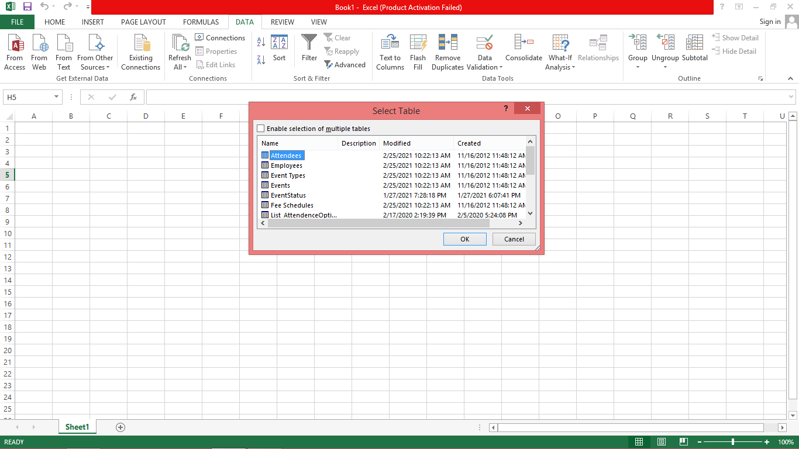

**Step 6** − Tables in a database are similar to the tables in Excel. Check the ‘Enable selection of multiple tables’ box, and select two or more tables. Then click OK.

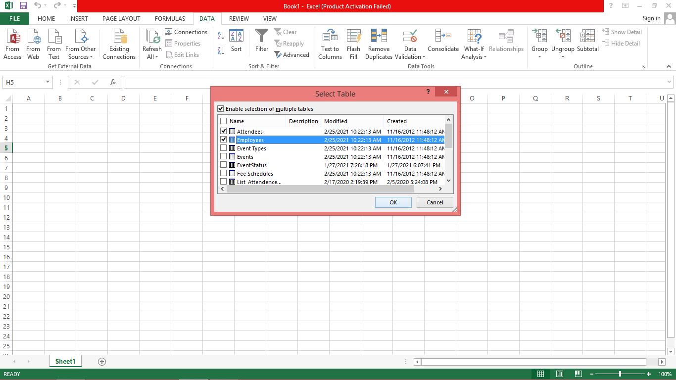

**Step 7** − The Import Data window appears. Select the PivotTable Report option. This option imports the tables into Excel and prepares a PivotTable for analyzing the imported tables. Notice that the checkbox at the bottom of the window - ‘Add this data to the Data Model’ is selected and disabled.

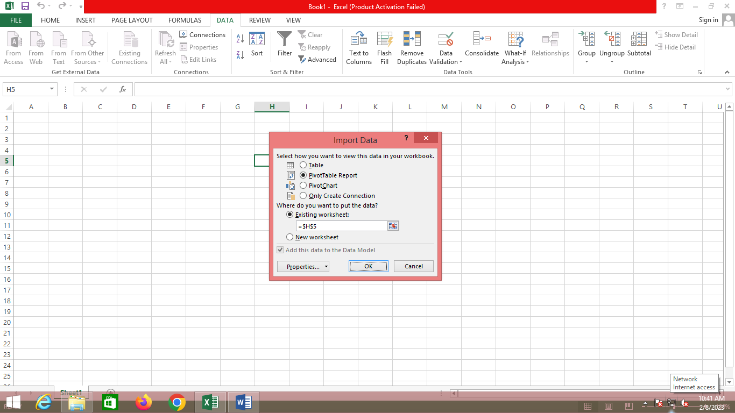

**Step 8** − The data is imported, and a **PivotTable** is created using the imported tables.

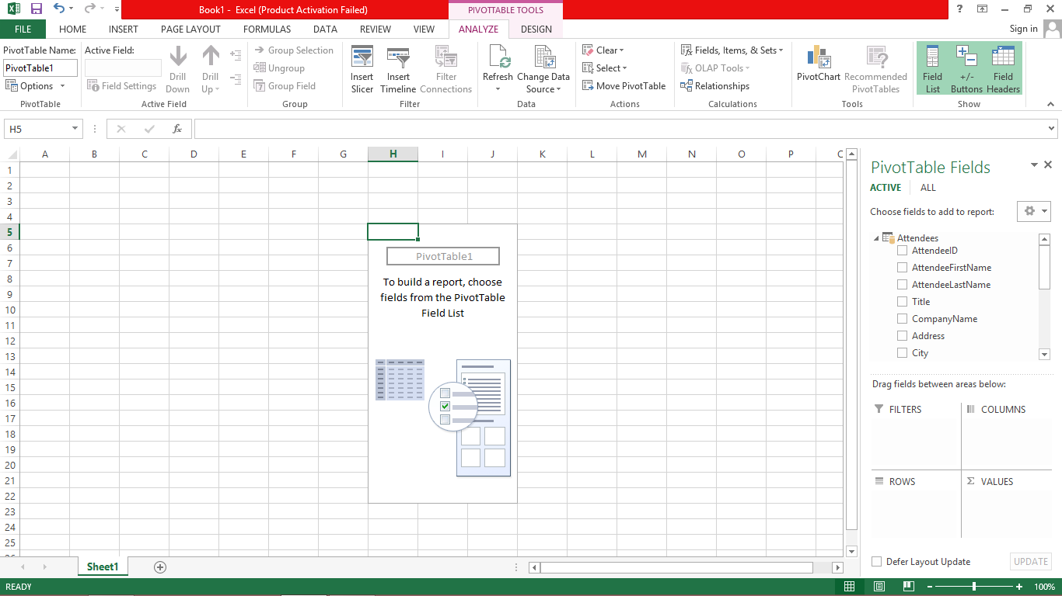

**Explore Data Using PivotTable**

**Step 1 –** Choose the required data fields from imported Employees and Attendees Tables.

**Step 2 –** Check the EmployeeId, Title fields from Employees Table and also check the AttendeeId, Title fields from Attendees table. Now that data has been shown in the Excel Sheet.

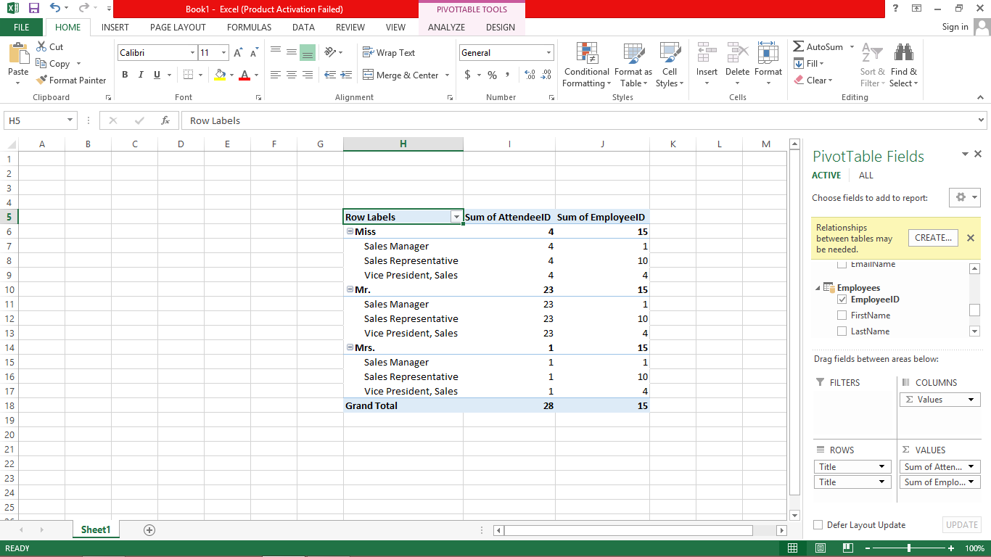

**Step 3 –** Right click on the Excel data. Then select the Filter option from box. In Filter option select the Value Filter.

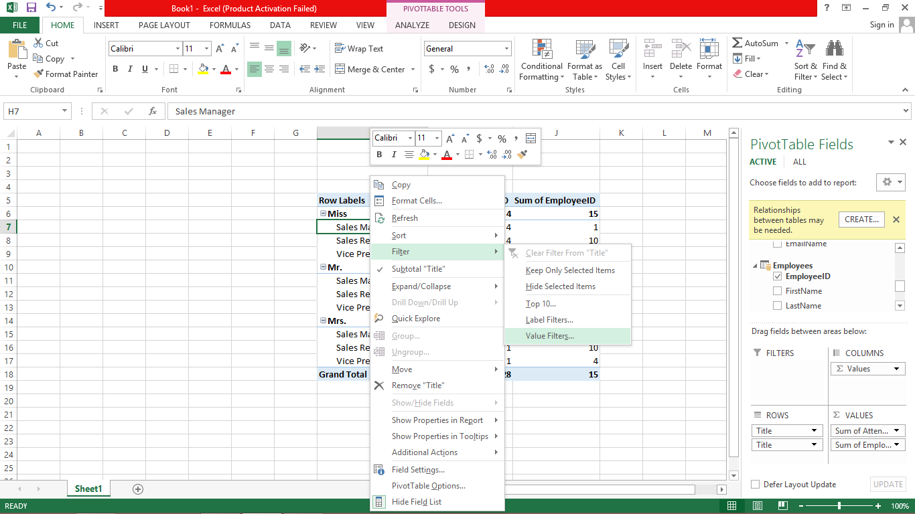

The Value Filters dialog box is appears.

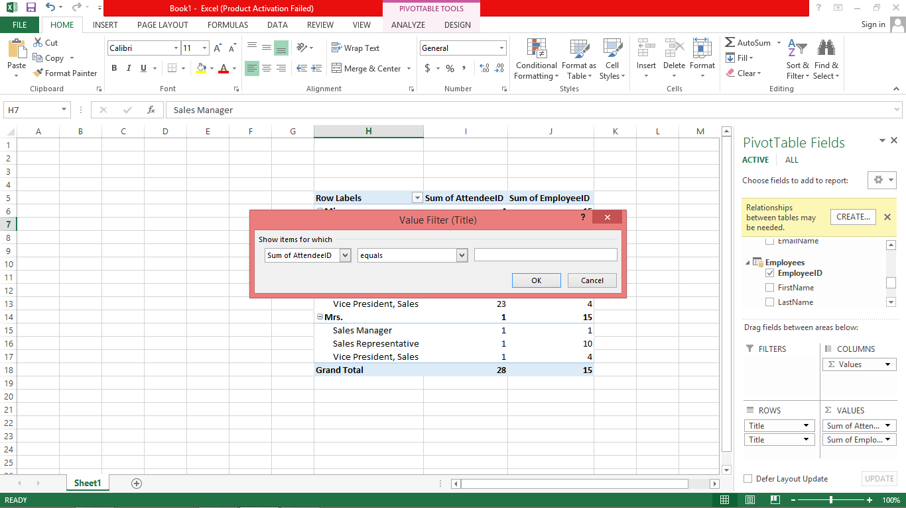

**Step 4 –**  Click the dropdown list button on left hand side and select the field for which you apply filter.

**Step 5 –** Now select the is less than filter from dropdown list.

[**Step 6**](https://e-next.in/) **–** Type 4 in the field.

**Step 7 –** Click OK.

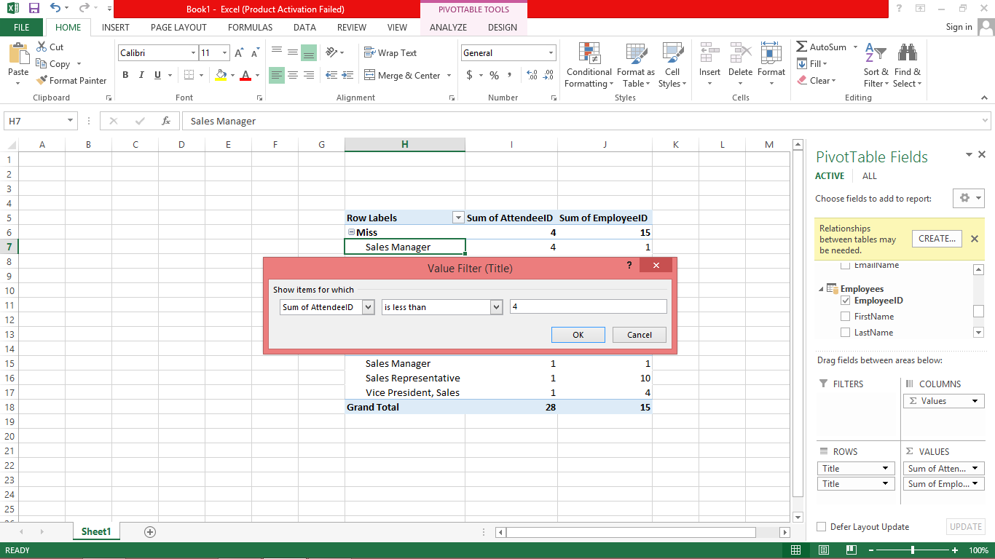

[The PivotTable displays only those regions, which has less than id 4 from AttendeeID Field.](https://e-next.in/)

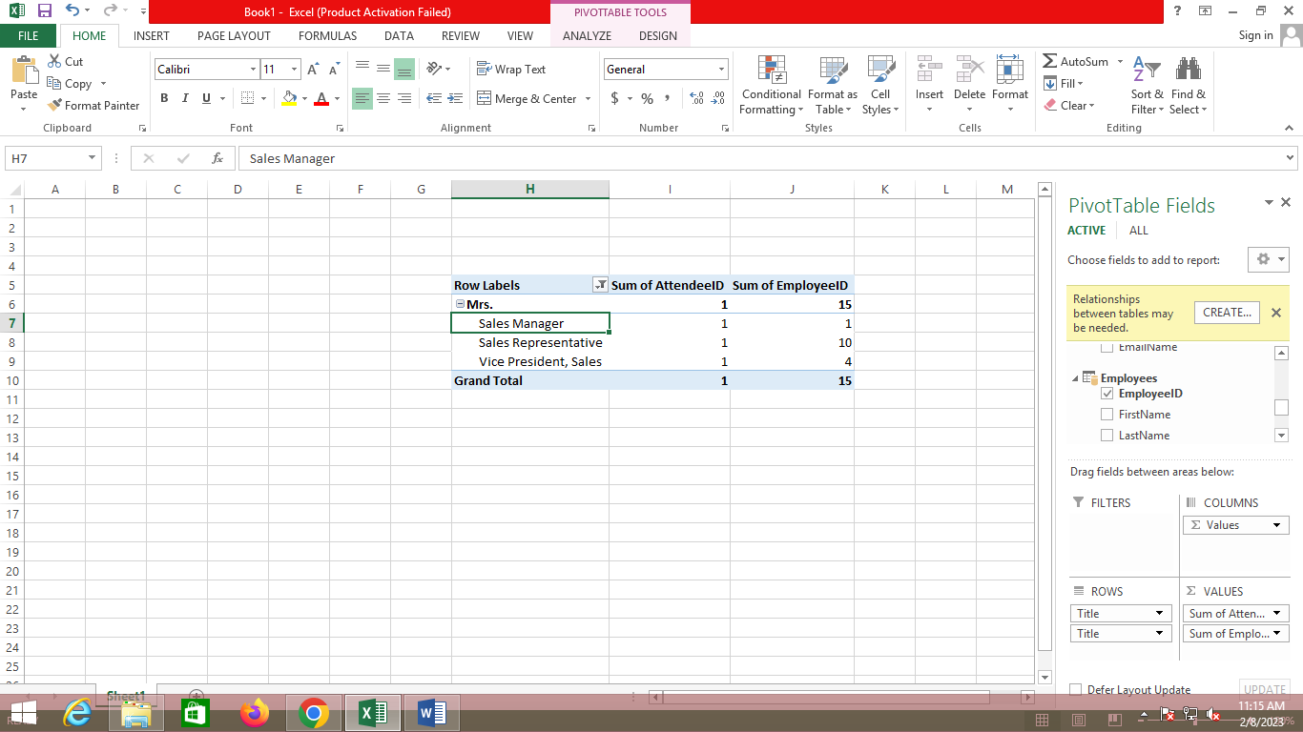

## **Create Relationship between Tables**

Relationships let you analyze your collections of the data in Excel, and create interesting and aesthetic reports from the data you import.

**Step 1** − Insert a new Worksheet.

**Step 2** − Create a new table with new data.

**Step 3** − Now you can create relationship between this new table and the other tables that already exist in the Data Model in Excel.

[On the sheet, in the PivotTable Fields List, click All. A complete list of available tables will be displayed. The newly added table will also be displayed.](https://e-next.in/)

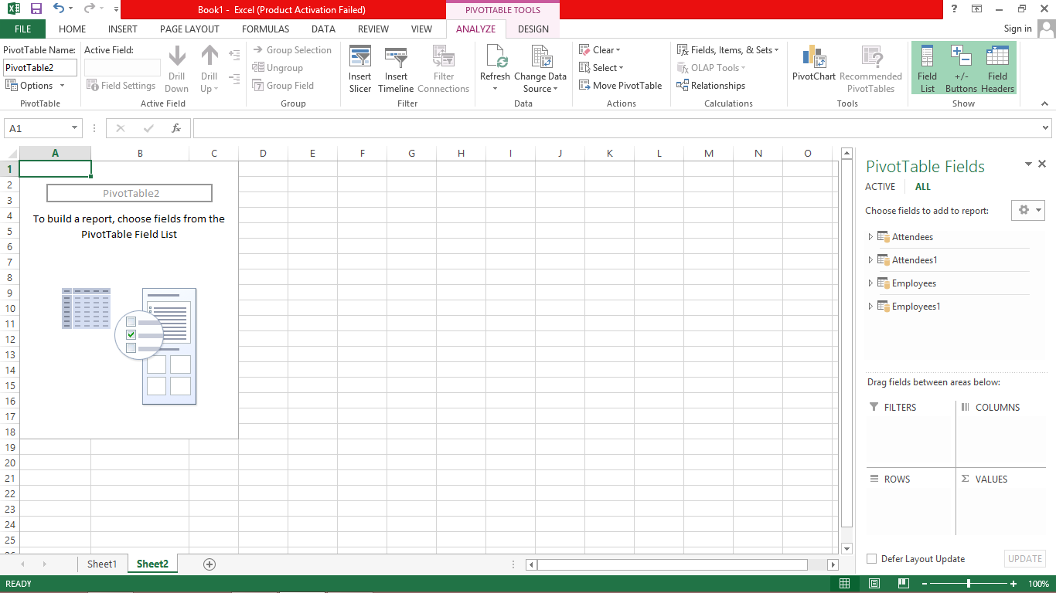

**Step 4** − Click on Employee, In the expanded list of fields, select EmployeeID And Title..

**Step 5** − Click on Attendees, In the expanded list of fields, select AttendeeID And Title. Excel messages you to create a relationship between tables.

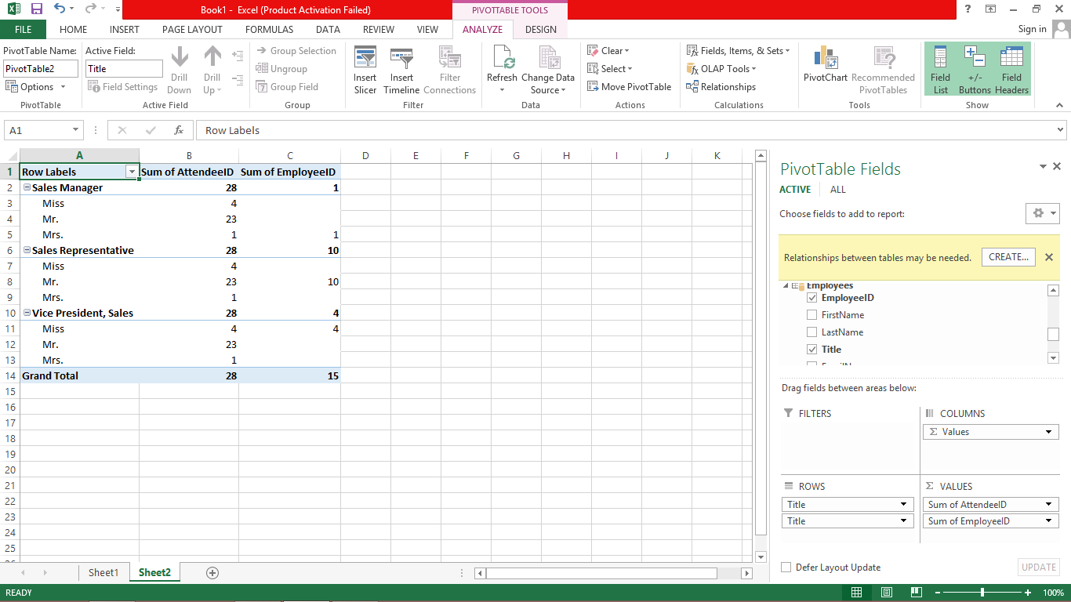

**Step 5** − Click on CREATE. The Create Relationship dialog box opens.

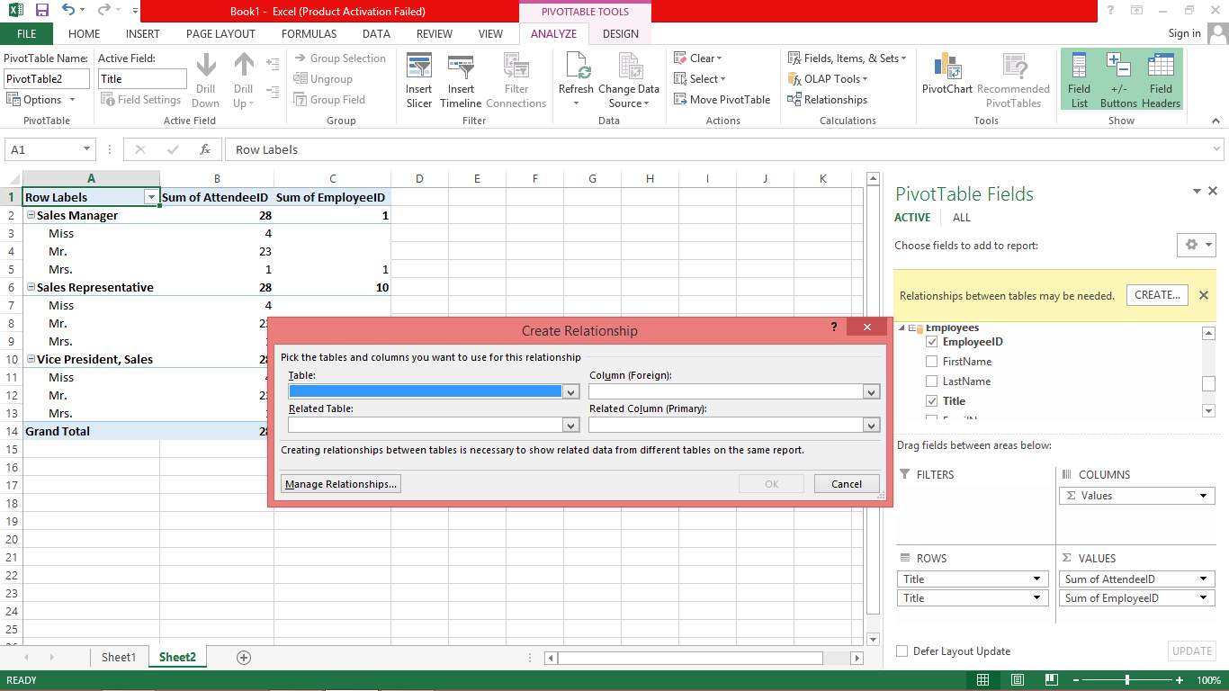

**Step 6** − To create the relationship, one of the tables must have a column of unique, nonrepeated, values. In the Employee table, EmployeeID column has such values. The table Attendees that we have created also has the AttendeeID column.

In Table select Employees.

**Step 7** − In Column (Foreign), select EmployeeID.

**Step 8** − In Related Table, select Attendees.

**Step 9** − In Related Column (Primary), AttendeeID gets selected automatically. Click OK.

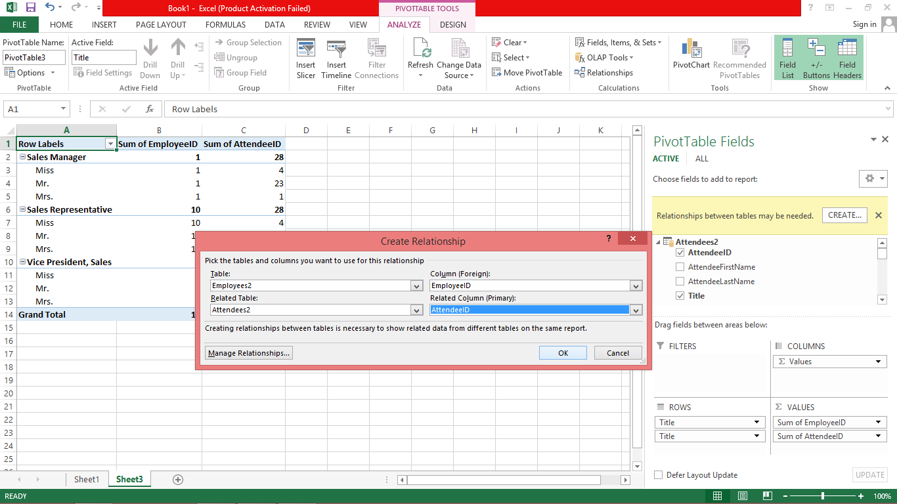

**Step 10** − The PivotTable is modified to reflect the addition of the new Data Field Sport.

Adjust the order of the fields in the Rows area to maintain the **Hierarchy**. In this case, Sum of EmployeeID should be first and Sum of AttendeeID should be the next, as AttendeeID will be nested in Employee as a sub-category.

